|  |  |  |  |  |  |  |
| --- | --- | --- | --- | --- | --- | --- |
| Fry | Summer | Fall | Smolts | AIC | Delta_AIC | weights |
| Power | Power | BH | Power | 394.472 | 0 | 0.2158 |
| BH II | Power | BH | Power | 396.284 | 1.813 | 0.0872 |
| Power | Power | BH | BH II | 396.352 | 1.88 | 0.0843 |
| Power | Power | BH II | Power | 396.444 | 1.972 | 0.0805 |
| Power | BH II | BH | Power | 396.472 | 2 | 0.0794 |
| Power | Power | Power | Power | 397.192 | 2.72 | 0.0554 |
| BH II | Power | BH | BH II | 398.146 | 3.675 | 0.0344 |
| BH II | Power | BH II | Power | 398.238 | 3.766 | 0.0328 |
| BH II | BH II | BH | Power | 398.284 | 3.813 | 0.0321 |
| Power | Power | BH II | BH II | 398.316 | 3.844 | 0.0316 |
| Power | BH II | BH | BH II | 398.352 | 3.88 | 0.031 |
| Power | BH II | BH II | Power | 398.444 | 3.972 | 0.0296 |
| BH II | Power | Power | Power | 399.115 | 4.643 | 0.0212 |
| Power | Power | Power | BH II | 399.126 | 4.655 | 0.0211 |
| Power | BH II | Power | Power | 399.192 | 4.72 | 0.0204 |
| Power | Power | BH | BH | 399.486 | 5.014 | 0.0176 |
| BH II | Power | BH II | BH II | 400.088 | 5.616 | 0.013 |
| BH II | BH II | BH | BH II | 400.146 | 5.675 | 0.0126 |
| BH II | BH II | BH II | Power | 400.238 | 5.766 | 0.0121 |
| Power | BH II | BH II | BH II | 400.316 | 5.844 | 0.0116 |

|  |  |  |  |  |  |  |
| --- | --- | --- | --- | --- | --- | --- |
| Fry | Summer | Fall | Smolts | AIC | Delta_AIC | weights |
| Power | Power | BH | Power | 394.472 | 0 | 0.2158 |

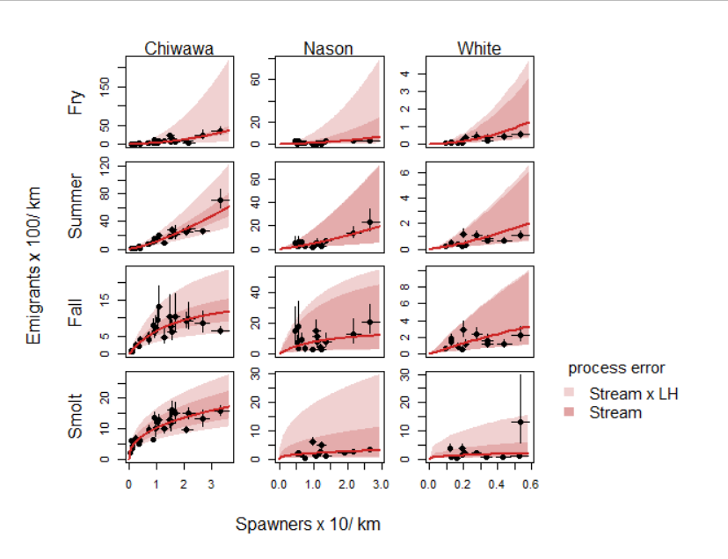

|  |  |  |  |  |  |  |
| --- | --- | --- | --- | --- | --- | --- |
| Fry | Summer | Fall | Smolts | AIC | Delta_AIC | weights |
| BH II | Power | BH | Power | 396.284 | 1.813 | 0.0872 |

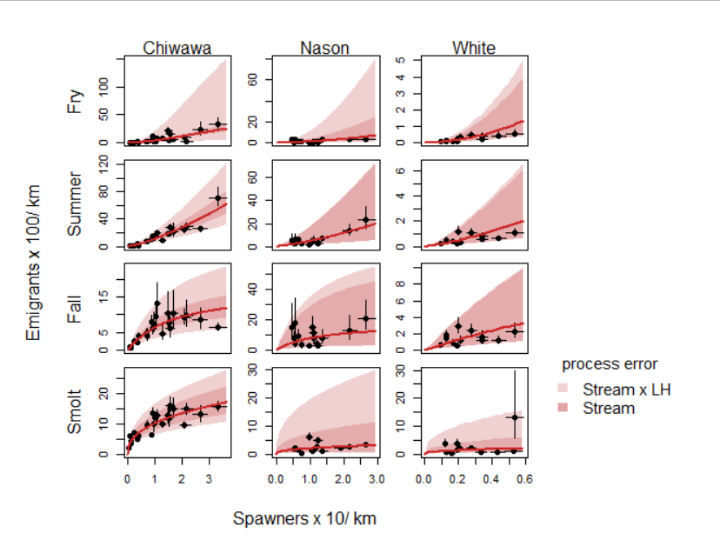

|  |  |  |  |  |  |  |
| --- | --- | --- | --- | --- | --- | --- |
| Fry | Summer | Fall | Smolts | AIC | Delta_AIC | weights |
| Power | Power | BH | BH II | 396.352 | 1.88 | 0.0843 |

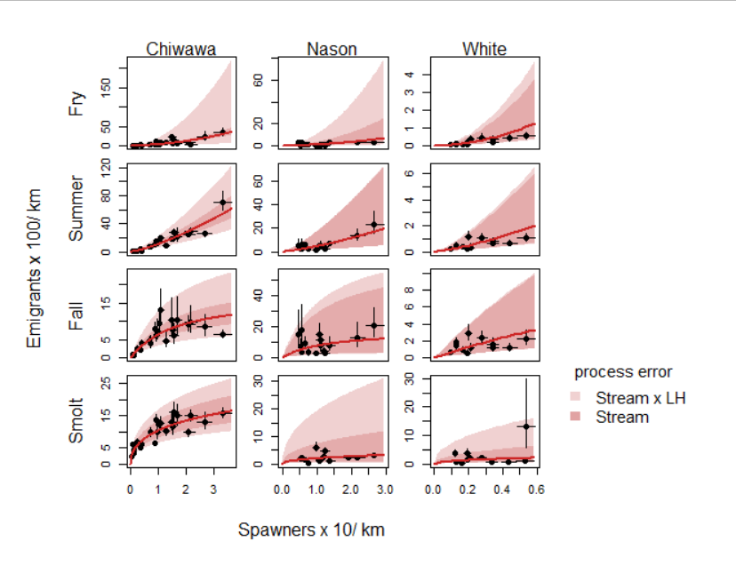

|  |  |  |  |  |  |  |
| --- | --- | --- | --- | --- | --- | --- |
| Fry | Summer | Fall | Smolts | AIC | Delta_AIC | weights |
| Power | Power | BH II | Power | 396.444 | 1.972 | 0.0805 |

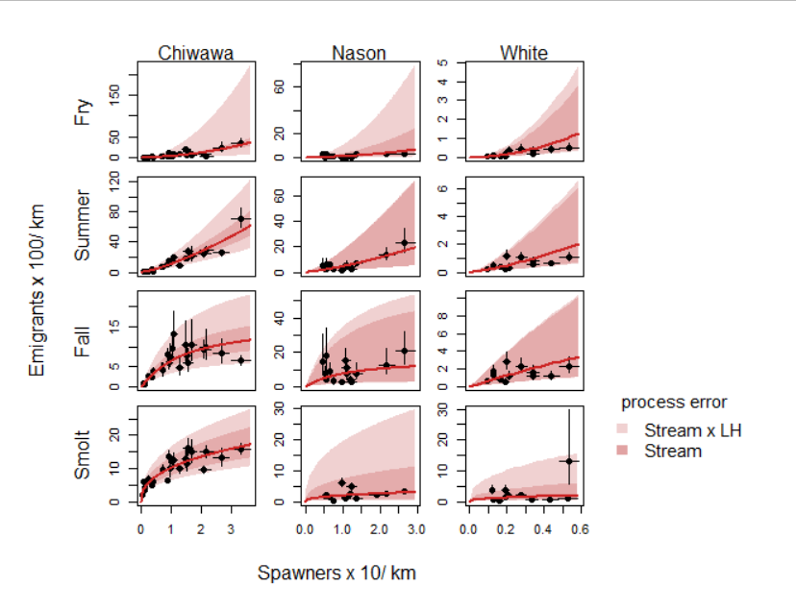

|  |  |  |  |  |  |  |
| --- | --- | --- | --- | --- | --- | --- |
| Fry | Summer | Fall | Smolts | AIC | Delta_AIC | weights |
| Power | BH II | BH | Power | 396.472 | 2 | 0.0794 |



|  |  |  |  |  |  |  |
| --- | --- | --- | --- | --- | --- | --- |
| Fry | Summer | Fall | Smolts | AIC | Delta_AIC | weights |
| Power | Power | Power | Power | 397.192 | 2.72 | 0.0554 |

